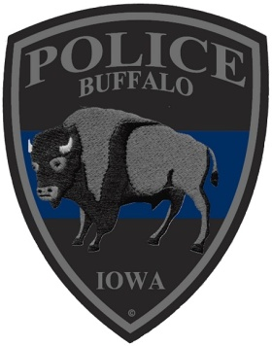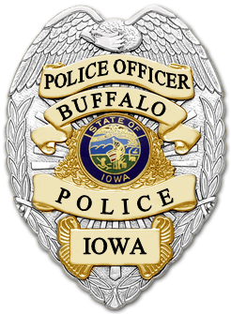
BUFFALO POLICE DEPARTMENT
Terry Behning; Chief of Police
413 3rd Street, Buffalo, Iowa 52728
(563)381-4733

Press Release

On March 18th, 2016 at 1915 hours the Buffalo Police Department and the Scott
County Sheriff’s Office responded to the report of a robbery in the 11800 block of S. Utah
Ave. in Buffalo, IA.
The suspect, identified as Barry P. Bennett Jr, was being transported to Country
Oaks facility by a Muscatine County Sheriff’s Office transport officer. Bennett did escape
the transport vehicle by breaking out the rear window. Bennett entered the front passenger
seat of the vehicle and assaulted the officer. Bennett fought with the officer and gained control
of the vehicle keys. Bennett took control of the transport vehicle after again assaulting the officer, causing minor injury.
Bennett led the Buffalo Police Department on a vehicle pursuit into Muscatine County. The Muscatine County Sheriff’s Office, along with the Muscatine Police Department and the Iowa State Patrol assisted in the pursuit which ended in the 1900 block of Hwy 38, in Muscatine County.
Bennett has been charged with robbery 2nd degree, theft 1st degree, felony eluding, assault on a jail officer with injury, operating while intoxicated 1st offense, and driving while license suspended.

Sgt. A. Gries #415
Buffalo Police Department

